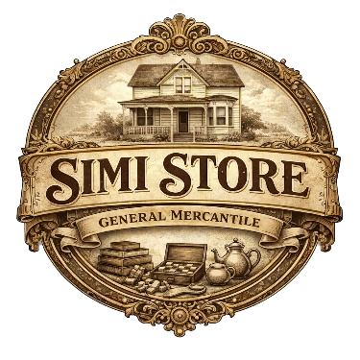
Volunteer Position: Simi Store Shopkeeper (Store Manager)

Shopkeeper Overview
The Simi Store Shopkeeper is a volunteer position with the Simi Valley Historical Society. It is a great way for someone with retail experience to get involved in the Community. This position reports to the Historical Society Executive Board and oversees its retail operations at Strathearn Historical Park in Simi Valley. This includes a 440 square foot dedicated store in the center of the Park, and approximately 60 square feet of souvenir, book and gift space in the Visitors Center. The person in this position will be able to influence the types of products sold, how display areas are set up and maintained, and store policies and practices. This person will also provide training as needed and work with the Historical Society to schedule volunteers to staff the store.

Key Responsibilities
Purchasing & Inventory
- Research and recommend the purchase of items that:
  - Have a historic theme,
  - Carry Strathearn Park or Simi Valley branding,
  - Have educational value, or
  - Are affordable for our School Tours program.

Store Operations
- Open and oversee the mercantile during:
  - School Tours. School Tours runs from 9:00am to Noon, two days a week, from Mid-January to Mid-May
  - Special Events. There is a special event each quarter, on a Saturday, that typically run for 6 hours.
- Ensure the store and displays are clean, stocked, and appealing
- Ensure that pricing is clearly labeled
- Ensure that cash handling and sales transactions are conducted according to established procedures
- Assess and maximize store staging and the storage of merchandise

Volunteer Coordination
- Work with the Historical Society Treasurer to schedule store volunteers
- Provide basic guidance and training for volunteers working in the shop
- Create a welcoming and organized environment for volunteers

Time Commitment
- Typical time commitment is about 6 to 10 hours per week.
- Attendance during some School Tour days and key events is preferred

Ideal Candidate
- Enjoys retail-style environments
- Organized and detail-oriented
- Creative with displays or merchandising
- Comfortable working with volunteers and the public
- Reliable and able to work somewhat independently

Bonus (not required):
- Retail, gift shop, or department store experience
- Personnel Management experience
- Knowledgeable in budgeting, purchasing, price setting, visual merchandising, and/or inventory

Benefits
- A wonderful way to use your retail experience in a unique historic environment
- The creative freedom to create a charming old-fashioned shop experience
- Join a team of friendly, passionate community volunteers
- Be a part of the Strathearn Historical Park experience

